Result - Base Minor

1) Python Libraries

Pandas

Numpy

Matplotlib

Seaborn

Wordcloud

Snscrape - For scraping the data

seaborn

Matplotlib

NLTK

2) Dataset -

The first dataset is scrambled from Twitter using snscrape.

<https://www.kaggle.com/datasets/arinjaypathak/indian-state-elections-2022-twitter-dataset>

3) Preprocessing Techniques

Tokenization

Stopword Remove

Lemmatization

Punctuation Remove

De-tokenisation

Url Remove

Double Spaces, Indents removal

4) Sentiment analyzer

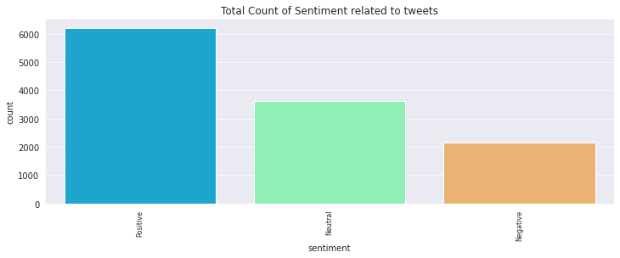

5) Wordcloud

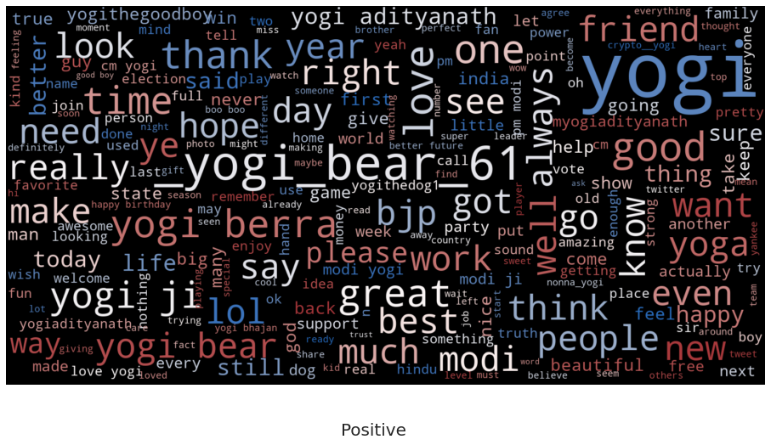

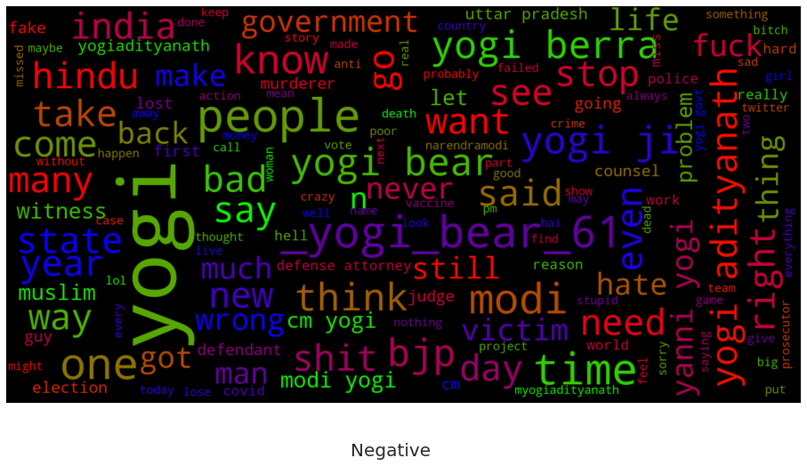

6) Feature Extraction Technique

TFidf

7) Classification Technique

Linear SVC

Random Forest

Soft Voting

8) Results

1. Linear SVC

**Testing**

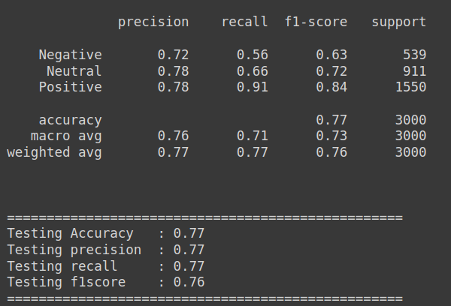

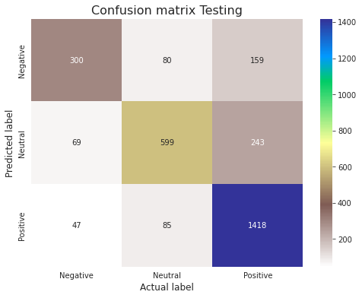

**Training**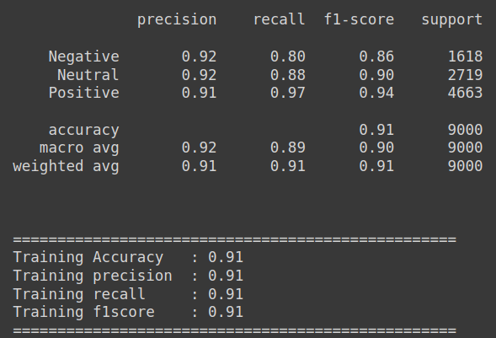

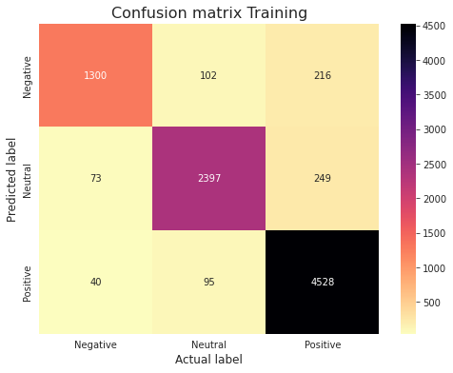

1. Random Forest

**Testing**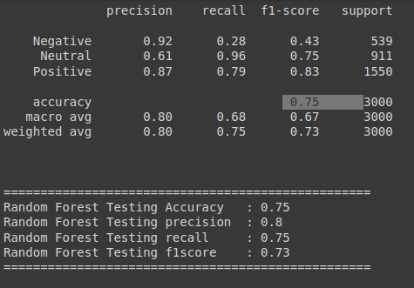

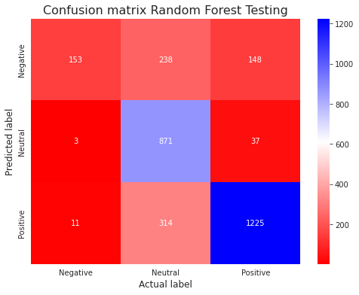

**Training**

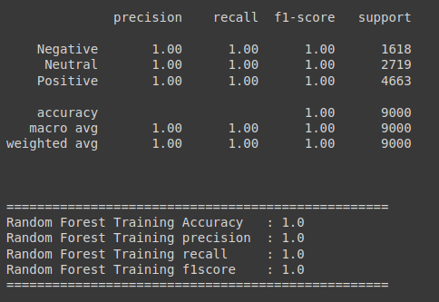

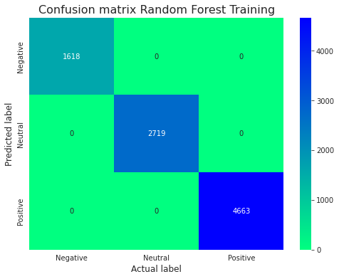

1. Soft Voting Classifier

**Testing**

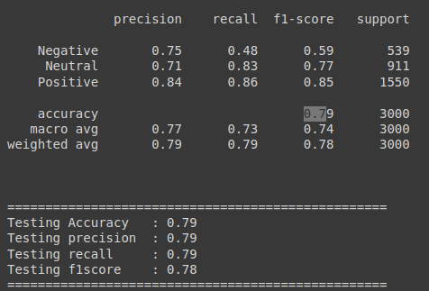

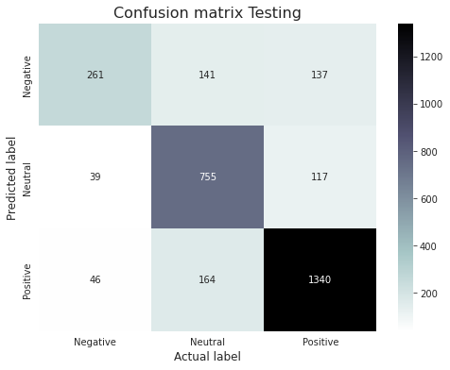

**Training**

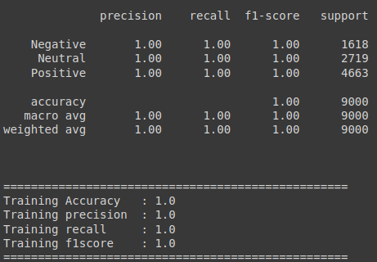

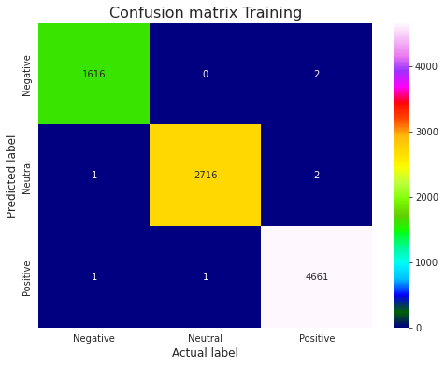

**Election Result Prediction Using Our Linear SVC Model**

